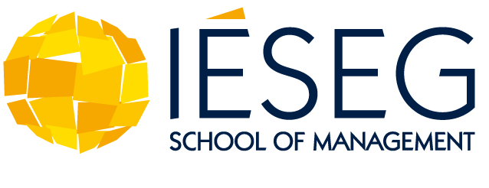
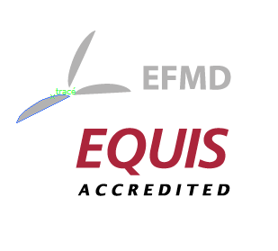

The Future of Global Economies: Responsible Management
Innovative Postgraduate Summer Course in Paris, Scholarships available

Paris, May 2012. IESEG School of Management in Paris offers for the first time a summer course opportunity for students with an advanced academic degree.
During two weeks in July 2012, the new postgraduate summer course will focus on “responsible management”. Course participants will learn how to lead the process of conducting business in line with sustainable development and social issues and will better come to understand the importance of underpinning economies with values to drive sustainable and inclusive growth. Through interactive sessions and case studies, students will be given an overview of the sustainability movement in the context of globalization, and the ways in which corporations are integrating environmental and social issues into strategy and operations.
The program combines lectures, group discussions, case studies, workshops and guest speakers and provides extensive networking opportunities. A main focus lies on the courses Social Entrepreneurship: Responsible Management for Sustainability and on Just in time supply chain management.
Scholarships for Summer Academy by GRLI
The Globally Responsible Leadership Initiative (GRLI), a worldwide partnership of companies and business schools, offers participants the opportunity to finance the IESEG summer course with a GRLI Young Ambassadors Scholarship (GYAS). Application deadline is the 11th of May 2012 (contact details below).
International Postgraduate Summer Academy at IESEG School of Management from 1th to 15th of July 2012 in Paris:
- Fees: 2350€, including courses, housing and extra curriculum activities
- Application deadline: 30th of May (For scholarships 11Th of May)
For further information about program, application and scholarships: summer@ieseg.fr or visit http://ww.ieseg.fr/postgraduate-summer-academy

Press contact: Nathalie Heredia, IESEG School of Management
Tel: + 33 1 55 91 10 10/ Email: n.heredia@ieseg.fr
www.ieseg.fr

About IESEG School of Management
IESEG School of Management is one of the top business schools in France, ranked 8th in 2011 by leading student magazine L’Etudiant. As a French Grande Ecole and member of the Conférence des Grandes Écoles IESEG is part of the most prestigious higher education institutions in the country. It is also awarded with the international accreditation EQUIS. Established in 1964 in Lille, the school has a second campus in Paris at La Défense, European biggest business hub. All Bachelor and Master Programs at IESEG are taught in English. At IESEG students have also access to the prestigious 5 year Grande Ecole Program. IESEG collaborates closely with the largest institute for basic research in Europe, the French National Centre for Scientific Research (CNRS). It was recently recognized as the No 2 business school in France for research (EducPro/L’Etudiant 2011). 85% of IESEG's faculty is international, and the school has a network of more than 170 partner universities in more than 40 countries.
Website : www.ieseg.fr

