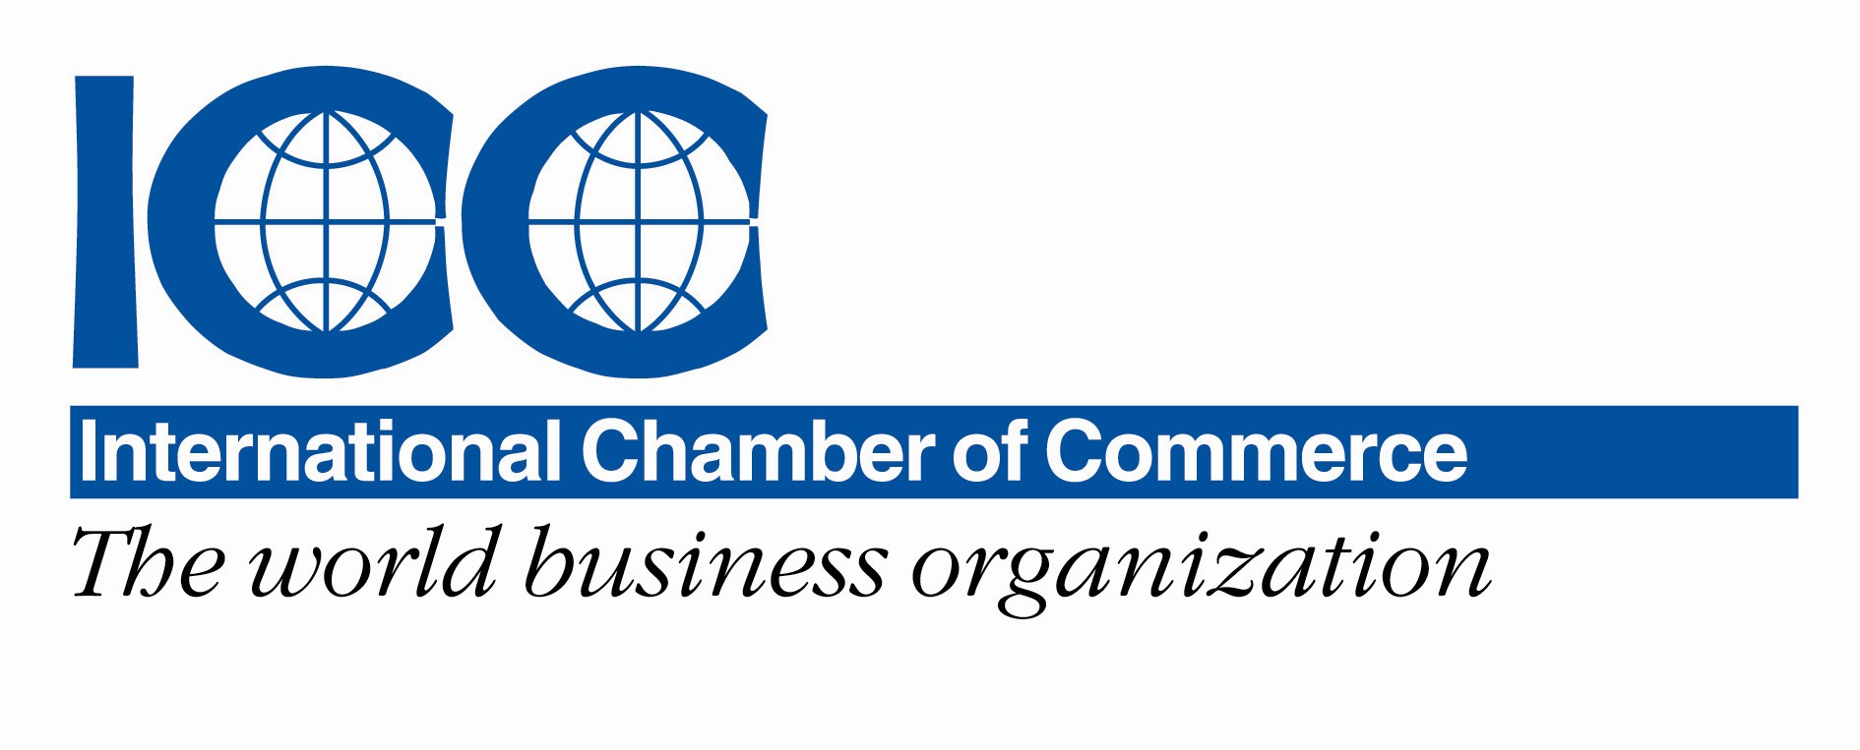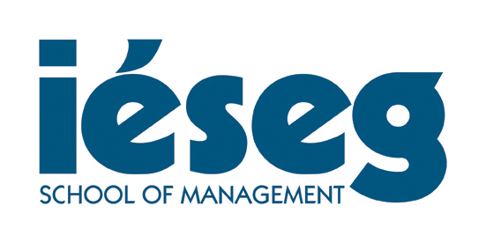

PRESS-RELEASE
13 -14 April 2012 in Paris
The World’s Best Business & Law Schools Compete For Negotiation World Championship at IESEG in Paris
IESEG School of Management in Paris is hosting in April the TNC negotiation event for 18 prestigious universities from around the world including Harvard, Kyoto University and Thunderbird

The Negotiation Challenge (TNC) is an esteemed platform in which students from countries across the world negotiate on important international topics. For the first time, TNC will be held at Paris from 13-14, April 2012, proudly organised by IESEG School of Management (France) and HHL Graduate School of Management (Germany).
Eighteen teams from 13 countries, negotiate at different venues throughout Paris to compete to win the prestigious TNC cup. During two intense days, the teams will negotiate at typical Parisian and prestigious venues like in cafés at Montmatre, in Parisian restaurants (Chez Jenny), at the TNC partner the International Chamber of Commerce Headquarters, and on the IESEG Campus in the iconic Grande Arche.
This Year’s Participants:
Warsaw School of Economics (Poland), Harvard Business School (U.S.), , CESA Business School (Colombia), ESCP Europe (France), ESSEC Business School (France), IESEG School of Management (France), HHL - Leipzig Graduate School of Management (Germany), Kazakhstan Institute of Management Economics and Strategic Research (Kazakhstan), Kyoto University (Japan), Reykjavik University (Iceland), S.P. Jain Institute of Management and Research (India), University of Bonn (Germany), University of California Hastings College of the Law (U.S.), University of Strathclyde (Scotland), The Chinese University of Hong Kong (China), The University of Economics (Czech Republic), London School of Economics and Business (U.K.), Thunderbird School of Global Management (U.S.)
The organization committee of TNC is available for more information concerning the background, goals, and procedures of the event. Additionally, you have the chance to talk directly to students of the participating teams or to accompany us editorially throughout the competition. Interviews with founders and organizers can be arranged on request.

Press contact: Nathalie Heredia, IESEG School of Management
T: + 33 1 55 91 10 18 / E: n.heredia@ieseg.fr

About IESEG School of Management
Established in 1964, IESEG School of Management is now ranked as one of the top 10 business schools in France. With campuses in Lille and Paris, the school delivers select bachelor’s and master’s programmes entirely in English. IESEG enjoys a unique association with CNRS, the largest basic science agency in Europe, that contributes to the school’s interdisciplinary approach to modern business problems. IESEG is a truly international institution, with more than 80 percent of tenured faculty coming from outside of France, and a strong network of 165 partner universities in 46 countries around the world.

About The Negotiation Challenge (TNC)
The Negotiation Challenge (TNC) was founded by PhD students of HHL and Harvard Law School during a joint project in 2007. IESEG and HHL, early on, realized the importance of the subject of negotiation. With TNC, IESEG and HHL are precursors in the European region in the field of negotiation.

Further information is available at:
http://thenegotiationchallenge.org/
www.youtube.com/user/NegotiationChallenge
https://www.facebook.com/NegotiationChallenge

